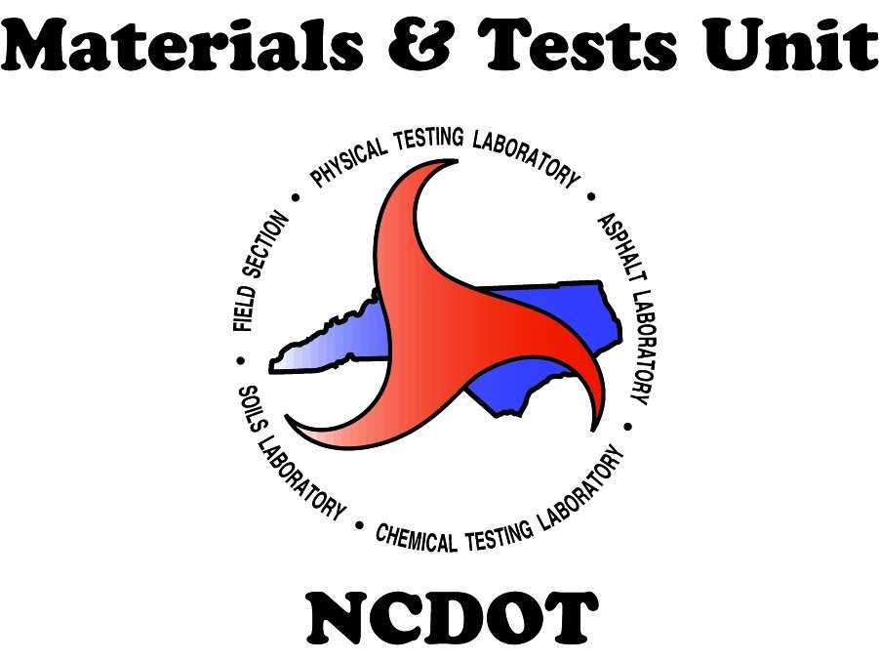

Standard Operating Procedure (SOP)

Ownership Change of a Ready-Mixed Concrete Facility

1. Purpose
To outline the procedure for updating the ownership of a ready-mixed concrete facility in the NCDOT system following a purchase or other ownership change.

2. Scope
This procedure applies to all ready-mixed concrete plants that are undergoing an ownership change and must be updated in the NCDOT Materials & Tests Unit system.

3. Responsibilities
The new owner or legal representative is responsible for ensuring that all required documents are submitted to the NCDOT M&T Unit in a timely and complete manner.

4. Procedure
- Step 1: Submit a formal request for ownership change, stating the reason for the transfer, to readymixinspections@ncdot.gov .
- Step 2: Provide a copy of the bill of purchase or any document verifying the transaction. (The purchase price may be redacted.)
- Step 3: Complete and submit the Ownership Update Form (available upon request).
- Step 4: Submit a copy of the most recent third-party inspection report and Certificate.
- Step 5: Submit a copy of the most recent fleet inspection report.
- Step 6: Submit a copy of the most recent scales inspection report.
- Step 7: Submit a copy of the most recent admixture calibration report.
- Step 8: Wait for the M&T Unit to review and approve the submitted documents. Once approved, the facility will be updated in the NCDOT system under the same RM number as before.

5. Contact Information
Email: readymixinspections@ncdot.gov
Materials & Tests Unit – NCDOT
For questions regarding this procedure, please contact the above email.

